**TEMASEK POLYTECHNIC**

**SCHOOL OF INFORMATICS & IT**

**DIPLOMA IN GAME DESIGN & DEVELOPMENT**

**AY2023/2024 OCTOBER SEMESTER (LEVEL 2) TERM A**

**GAME MATH AND PHYSICS (CGE2C15) TERM A**

**Project Documentation (10%)**

|  |  |
| --- | --- |
| **Class** | P03 |
| **Name as in register** | Low Tong Ee Thom |
| **Group #** | **5** |
| **Topic covered** | Particle system |
| **YouTube URL** | Make sure the link is shareable! |

**You must submit:**

* **A discussion about the** **Technical Problems & Solutions encountered**
* **A reflection about this assignment, and also of GMAPS.**

**Each question is on a separate page below.**

1. **Technical Problems & Solutions**

**Discuss the *technical* problems you faced while writing your code, and how you overcame them.**

**Technical problems do NOT include problems you might have had with time-management, knowledge of basic GMAPS topics, illnesses, part-time work, broken computers, lost files, or other distractions, etc.**

**Focus on**

* **Problems you had in understanding concepts related to the chosen topic, and how you managed to gain a better understanding, e.g., via online references, use of ChatGPT and other AI, etc. Make sure you list all references used.**
* **Problems you had in coding your demo implementation, and how you managed to overcome these. Give specific examples.**

**Introduction:**

As this is my first time working with VFX graph, I find hard to understand on how to even make particles. So, when I first started out, I decided to have a road map to know where to start.

1. Try to create a single strand of Grass.
2. Making a patch of grass
3. Adding additional features.

**Making Grass:**

The most difficult thing was getting the grass to be rendered as a particle. There were only two ways to render the particle. Individual particle or as a particle strip. I understood how to render using individual particle, but I find it hard to render them together using the strip.

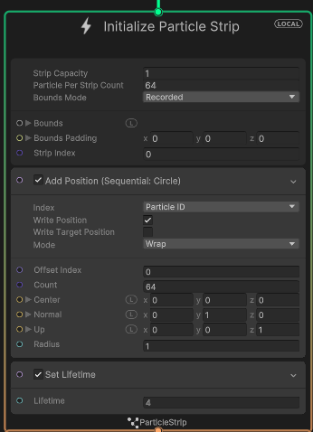

At first, I could not figure if the particle strip position is added to either the particle strip or the individual particles in the strip.

Even after reading the [documentation](https://docs.unity3d.com/Packages/com.unity.visualeffectgraph@12.1/manual/Block-IncrementStripIndexOnStart.html?q=particle%20strip), it still does not give a good idea on how the particle strip works. In fact, there is nothing stated on how to use particle strip on the unity documentation.

***How I solve it:***

I did quite a bunch of research on how to render particle strip. What help me was the 6 part tutorial video series by [Thomas Iché](https://www.youtube.com/@thomasiche8734/playlists). Where it the 4th and 6th tutorial teaches how to use particle strip for visuals like lighting and hair.

When spawning the grass, the particle strip will apply changes to every particle assign to that strip. So the changes will be applied to every particle in the initialize particle strip. The mesh will then be made as Unity connect the particles together to form a **single quad** which can be used to apply the texture.

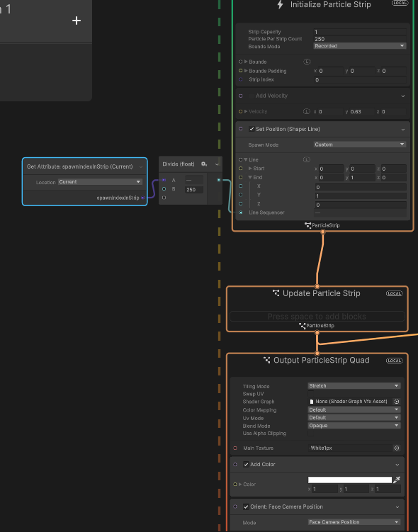

How a sample visual script look like to render a line using particle strip

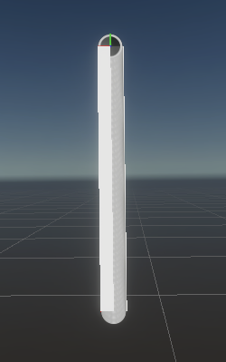

How the strip would look like in Unity

**Figuring out how to render a patch of Grass**

The next difficulty come which is how to render particles in a particle? Throughout the documentation, there were nothing about being able produce more particles from existing particles. So, I need to know,

1. How to have particles to throw out more particles
2. How to group up this particles and particle strip to form a terrain

**How I solve it:**

Thanks to [Thomas Iché](https://www.youtube.com/@thomasiche8734/playlists) , his 6th tutorial introduce GPU events and how to utalise them. It was not stated in the unity documentation since it is considered an **experimental block.** GPU events allow particles to throw out event in the GPU to signal other listeners like an observer pattern. This makes particle call out events to start spawning other particles.

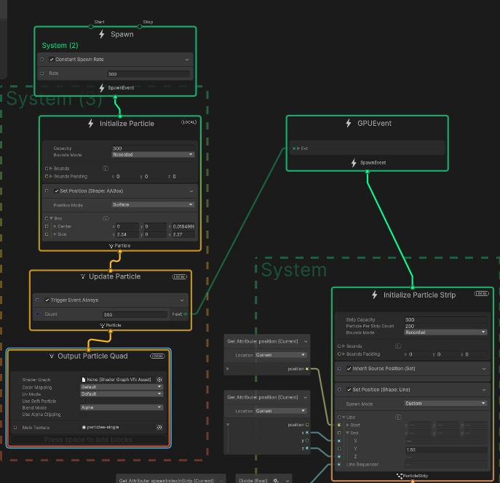

A simple script to make the a square patch using particle system

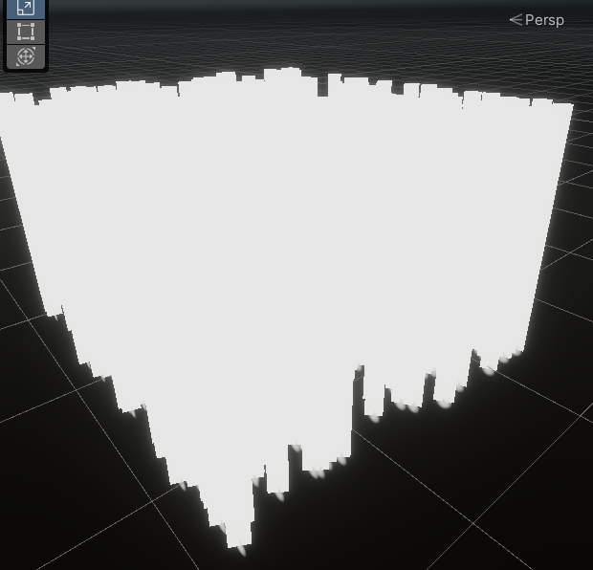

The end result is a square patch using GPU event

Next is how to render the grass in not just a square patch but rather in a terrain.

1. **Reflections**

**Reflect on:**

* **Your project, including the presentation and implementation parts. Discuss how useful you found the project work (e.g., relevance to game development, development of your technical knowledge, development of your programming skills, etc.) and how you approached it (e.g., your attitude, self-discipline, independence in learning, etc.).**
* **GMAPS as a whole. You can also use the discussion points suggested above here (e.g., relevance to game development, your attitude, etc.).**

1. **Project Reflection**

Your answer here (minimum 150 words for a *pass* grade) …

1. **GMAPS reflection**

Your answer here (minimum 150 words for a *pass* grade) …